Multi-Agent Maritime Navigation System

Functional Overview

Looking at traditional command structures on vessels, the following high-level schema can be created as an inspiration for a multi-agent maritime command system.
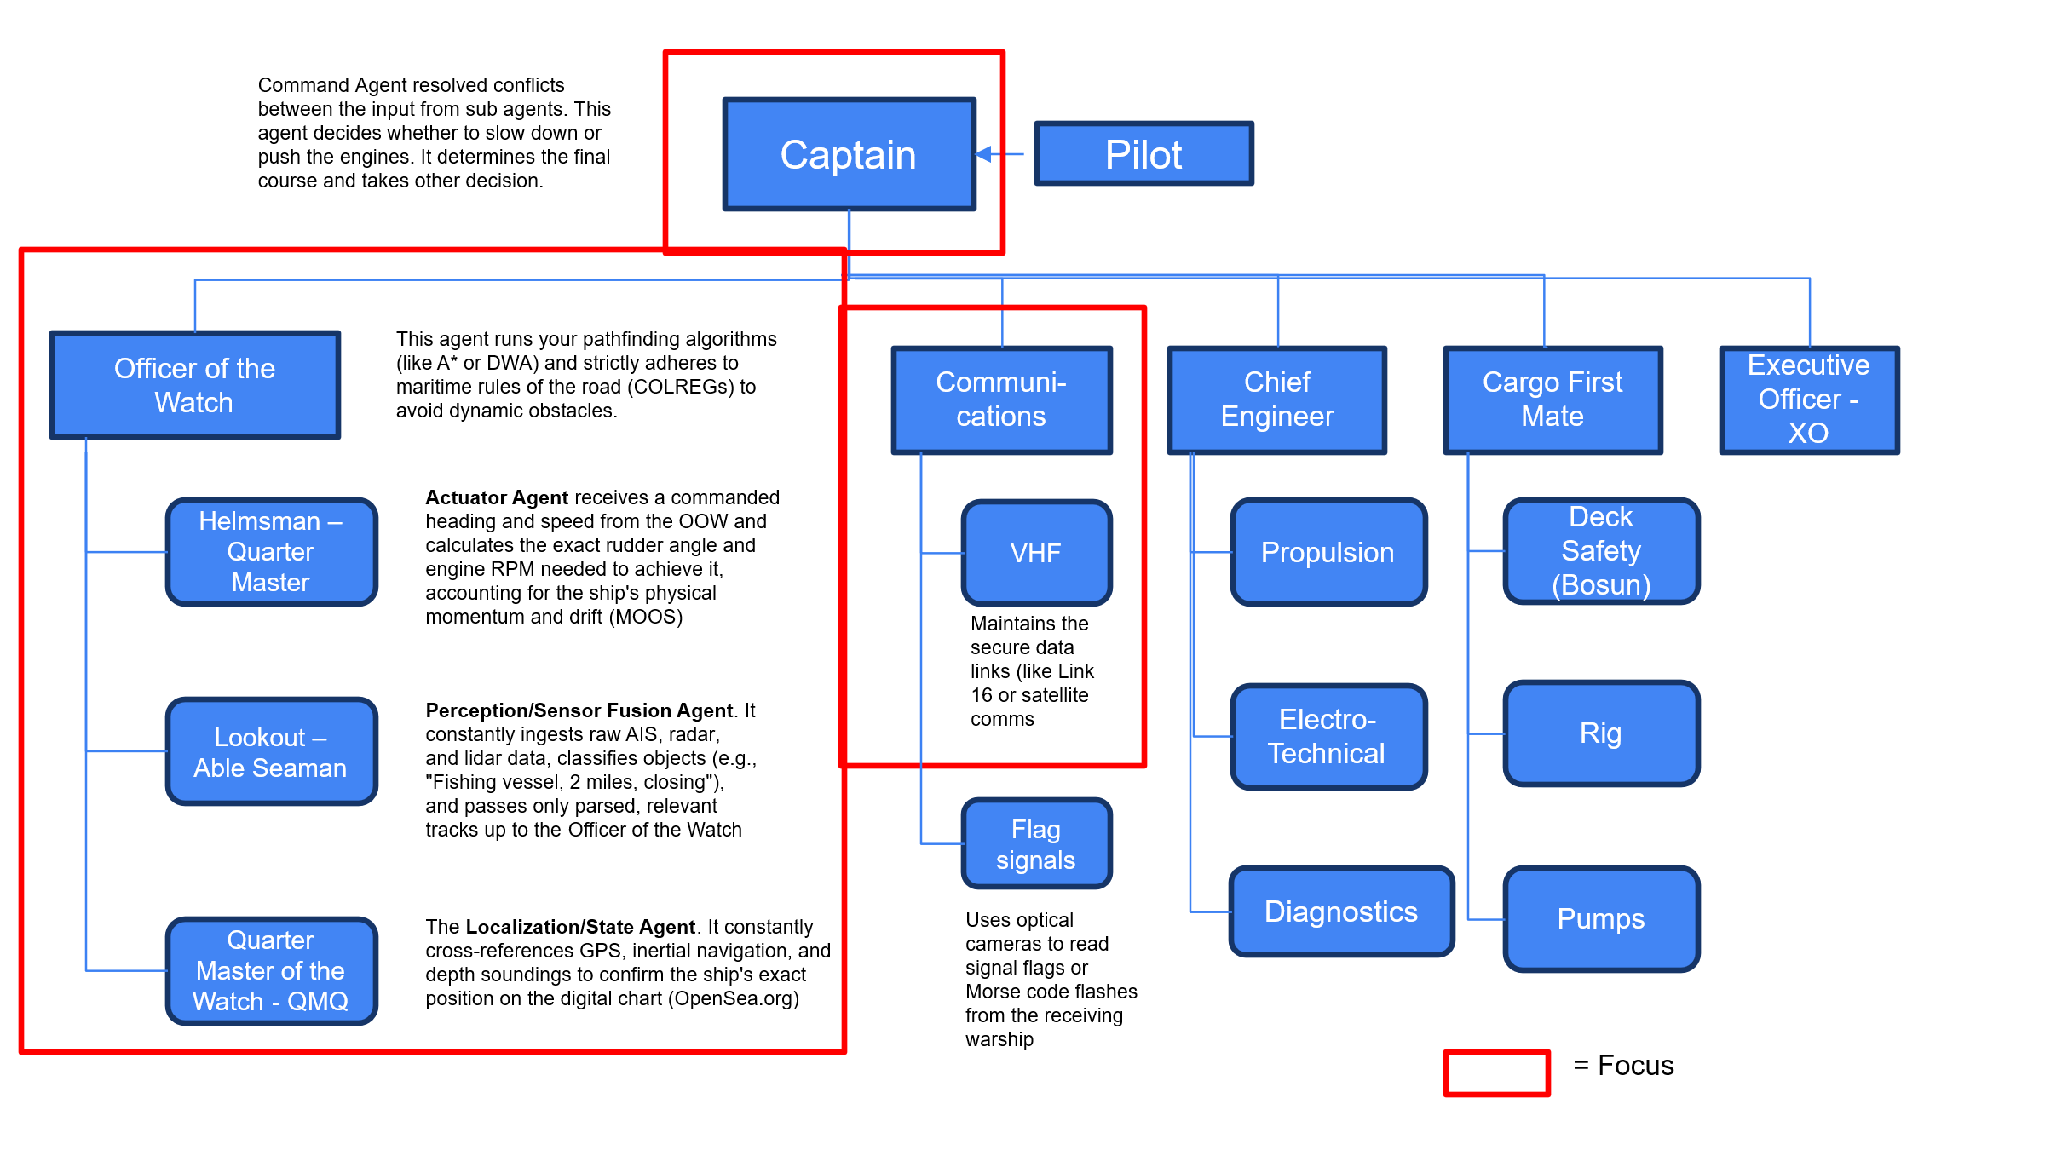
All communication will be text-based as these are LLMs. Where this textual data comes from other systems such as Radar, AIS, VHF, visual information, Maps (situational awareness), GPS, etc we will start using text as a basis. In the future other interfaces can be created (e.g. NMEA, direct VHF, etc).
The main goal of this project is to show that an auto pilot can be created using inductive methods where LLM-based sub-agents are exposed to agentic training data extracted form textual resources such as COLREG, incident report, simulations, maritime text books, etc.
To start, we will create the multi-agent architecture using (small) LLMs, prompts and skill files. Around a number of these LLMs (for the ones training data is available), we will then create an agentic harness including memory, re-ranking, reflection, (multi-hop) reasoning, tools (to access other systems), etc using training data extracted form the textual resources for RAG, KG-RAG, SFT, and RLHF to fine tune the agentic components. For traditional components (MOOS, Maps from OpenSea.org, VHF, etc.), we will use a LLM as interface. This is the only way to create a multi-agent system that uses a uniform method of communication between the agents. Also, this is compatible with the format in which the agentic training data is extracted from the textual resources.

Other interesting issues to investigate is how to avoid over-communication between the agents and agentic orchestration by the Command Agent. Human ship bridges operate on a concept called "Bridge Resource Management" (BRM). It relies heavily on challenge and reply. The agents shouldn't just pass data; they are programmed with threshold alerts. For example, if the Navigation Agent commands a course that takes the ship into too-shallow water, the Engineering/Sensors Agent should have the authority to trigger an "override/alert" state to the Command Agent. We could use this for inspiration when we get to this part of the system.

The first Level of the Command Architecture

On the highest level we can see the following main agents:
1. The Command Agent (The Captain or Commander)
- Role: The executive decision-maker and orchestrator. Assisted by Pilot if applicable.
- Inputs: Mission orders from the fleet, status reports from all other agents.
- Outputs: Broad directives (e.g., "Proceed to Rendezvous Point Alpha," "Abort UNREP due to weather").
- Logic: It does not calculate routes; it resolves conflicts. If the Engineering Agent says "engine overheating" and the Comms Agent says "we must meet the destroyer in 2 hours," the Command Agent decides whether to slow down or push the engines.
2. The Navigation Agent (The Officer of the Watch)
- Role: The real-time driver.
- Inputs: Destination from Command Agent, radar/sonar/AIS data, weather data.
- Outputs: Helm (rudder) and Lee Helm (engine throttle) commands.
- Logic: This agent runs your pathfinding algorithms (like A* or DWA) and strictly adheres to maritime rules of the road (COLREGs) to avoid dynamic obstacles, use maps from OpenSea.org for situational awareness and to determine free navigation space. Calculates course and is aware fo the ships physical momentum and drift.
3. The Engineering Agent (Chief Engineer)
- Role: The internal health monitor.
- Inputs: Sensor data from engines, generators, hull integrity, and fuel tanks.
- Outputs: Maximum available speed, power distribution, and maintenance alerts.
- Logic: It acts as a constraint on the Navigation Agent. If the Nav Agent asks for 100% thrust, the Engineering Agent might limit it to 80% to prevent a failure.

4. The UNREP/Cargo Agent (First Mate)
- Role: The specialist. Naval supply ships have one unique, highly dangerous job: Underway Replenishment (UNREP) — transferring fuel and ammo to a warship while both are moving at 12-15 knots, just 150 feet apart.
- Inputs: Draft/trim data, tension metrics on the physical transfer lines, distance to the receiving ship.
- Outputs: Micro-adjustments to speed and heading to maintain exact station-keeping alongside the warship.
- Logic: When an UNREP begins, this agent temporarily overrides standard navigation to execute hyper-precise dynamic positioning.
5. The Communications Agent (Fleet Interface)
- Role: The API to the outside world.
- Inputs: External API calls, fleet formations, distress signals.
- Outputs: Filtered objectives fed to the Command Agent.
6. Executive Officer (XO):
- Role: The second-in-command. Handles all administrative and daily scheduling tasks so the Master can focus purely on external situational awareness and critical decisions.
- As there are no persons onboard, this job is highly reduced compared to manned vessels.

Agent and Sub-Agent Relationships
Looking at the focus areas, we can then see the following agent - sub-agent relationships
The Command Agent (The Captain or Commander)
The Command Agent resolved conflicts between the input from sub agents. This agent decides whether to slow down or push the engines. It determines the final course and takes other decision. For now we do not include a pilot function. The command agent communicated with the Navigation Agent and with the Fleet Interface (aka communication) Agent.
The Navigation Agent (The Officer of the Watch)
This agent calculates the route and strictly adheres to maritime rules of the road (COLREGs) to avoid dynamic obstacles. The Navigation Agent has 3 sub-agents to assist it with its work. The results are communicated to the commander. The Navigation Agent communicates has the following sub-agents to its disposal to do its work:
- The Actuator Agent receives a commanded heading and speed from the OOW and calculates the exact rudder angle and engine RPM needed to achieve it, accounting for the ship's physical momentum and drift. This will be implemented using a LLM in combination with MOOS. Passes this information to the Navigation Agent.
- The Perception – Sensor Agent . It constantly ingests raw AIS, radar, and lidar data, classifies objects (e.g., "Fishing vessel, 2 miles, closing"), and passes only parsed, relevant tracks up to the Navigation Agent.
- The Localization/State Agent. It constantly cross-references GPS, inertial navigation, and depth soundings to confirm the ship's exact position on the digital chart (OpenSea.org). This is where the situational awareness is determined.
The Communications Agent
We implement this agent as one (no hierarchy yet). Maintains the VHF communication for this moment. In the future one could expand this using flag signals, incoming (SatLink) cables and wires, etc.
So, we start with 6 agentic components, all initially implemented using a LLM and Prompts/skill files. We build them from there.
Technical Architecture and Development Plan
September 2026 Deliverable
1. Introduction
The objective of this project is to investigate whether a modular multi-agent Large Language Model (LLM) architecture can support autonomous maritime navigation by combining sensor information, VHF communication, and COLREG-based reasoning into a single decision-making framework. The focus is to demonstrate coordinated decision making in a simulated environment while maintaining a modular architecture suitable for future expansion.
The September deliverable intentionally limits the scope to the core functionality required to validate the concept while providing a foundation for future extensions.
2. Project Objectives
Scientific Objectives:
• Investigate multi-agent LLM systems for maritime navigation.
• Evaluate specialized agents versus a monolithic model.
• Explore fine-tuning using simulation-generated data.
• Reasoning traces extraction from structured manuals/reports
• Evaluation of the effectiveness of a COLREGs agent on board
Engineering Objectives:
• Develop a modular architecture.
• Implement standardized communication.
• Deliver a working simulation.
September Deliverables:
• Multi-agent architecture consisting of:
- Command Agent
- Navigation Agent getting assistance from:
- The Actuator Agent (Helmsman)
- The Perception – Sensor Agent (able seaman on the outlook).
- The Localization/State Agent (quarter master of the watch, maps, GPS, etc).
- Communication Agent
In additional, the model will contain a Logging framework (more missions = more training for the models) and a Integrated simulation demonstration (MOOS)

3. System Overview
The architecture consists of specialized agents that communicate using standardized JSON messages over TCP. The Central Agent combines outputs from the lookout agent, VHF Agent, and officer of the watch agent to generate navigation commands, which are verified by the COLREG Agent before execution. All voyages and interactions will be logged for labelling and further model training.
4. Proposed Architecture

Simulation Environment
VHF incoming → Communication Agent
Ruther and speed - MOOS <-> Actuator Agent
AIS/RADAR → Perception – Sensor Agent
GPS and Situational Awareness (shallow waters...) → Localization/State Agent
Navigation Decisions (including COLREG) → Navigation Agent

All input and ultimate decisions → Command Agent.
Command Agent <→ Navigation Agent → Simulation Controller → Logging Framework
Command Agent <→ Communications Agent

Navigation Agent <-> Localization/State Agent
Navigation Agent <-> Actuator Agent
Navigation Agent <-> Perception – Sensor Agent

5. Agent Responsibilities

Command Agent:
- Combines information from all agents.
- Generates commands (turn port/starboard, stop, resume, set speed, sound_signal).
Communications Agent:
- Interprets incoming VHF communication.
- Determines intent and required actions.
Navigation Agent:
- Verifies compliance with COLREGs.
- Approves or rejects proposed maneuvers with justification.
Actuator Agent
- Receives a commanded heading and speed from the Navigation Agent
- Calculates the exact rudder angle and engine RPM needed to achieve it, accounting for the ship's physical momentum and drift (MOOS)
Perception/Sensor Fusion Agent:
- Processes AIS/RADAR.
- Filters relevant vessels.
- Estimates collision risk.
Localization/State Agent:
- Access to API for water depth.
- Full situational awareness using maps
- Gives the captain an idea of where it is allowed to navigate.

6. Communication Architecture
All agents communicate using standardized JSON messages containing timestamps, source agent, message type, and payload. This ensures modularity and simplifies integration of future agents.
7. Skill Files
Each agent uses dedicated skill files describing its reasoning strategy.
Actuator Agent: Communicates in detailed Natural Language from and to MOOS. MOOS does most of the work/
Perception/Sensor Fusion Agent: takes input from AIS for now and later Radar and visual (Lidar) data and communicated that in natural language to the Navigational Agent.
Localization/State agent has an interface to openseamaps.org and communicated free navigations space and important aspect of the situational awareness to the Navigational Agent (e.g. “a rock on the right, shallow area on the left, cannot navigate left or right, free navigation space is only forward and backward”, ….)
Communications Agent: maritime phraseology and intent extraction.
Navigational Agent: rule interpretation and validation.
Command Agent: situation assessment and decision synthesis.
8. Language Models
Development proceeds in three stages:
1. GPT-5 series via API for rapid prototyping.
2. Local open-weight models (Qwen 8B or Mistral 7B) later once we have data and we can start the fine tuning of an agentic architecture.
3. Fine-tuned local models using simulation data.

Data we can use for fine-tuning:
Command Agent: Incidents, data NavTrain, ...

Navigation Agent: COLREG, Training and educational handbooks on maritime navigation.

Actuator Agent (Helmsman): MOOS, no fine tuning needed
Perception – Sensor Agent (able seaman on the outlook): just data fusion to text, no fine tuning
Localization/State Agent (quarter master of the watch, maps, GPS, etc): translation maps to text

Communication Agent: translation between voice and transcriptions. Later: VHF protocols.

9. Logging Framework
Every simulation records sensor data, agent outputs, decisions, COLREG validation, executed commands, and voyage outcomes. These logs will be used for debugging, evaluation, and dataset creation.
10. Fine-Tuning Strategy
Simulation voyages generate supervised training examples consisting of ship state, contacts, VHF messages, agent outputs, and the desired manoeuvre. Initial fine-tuning focuses on the Central Agent. We shall then also define which components to include in each of the agentic harness of the (sub) agents.
11. Extraction of Reasoning Traces from Documents
A specialized pipeline consumes documents and extracts reasoning traces if it finds any. These are used alongside the central agent's skill file to augment its reasoning power.
12. Development Roadmap
Phase 1: Architecture
Phase 2: Individual Agents
Phase 3: Reasoning Traces
Phase 4: Integration
Phase 5: Evaluation
Phase 6: Local Deployment
Phase 7: Fine-Tuning
13. Evaluation
Engineering metrics: latency, GPU usage, communication overhead.
Navigation metrics: collision avoidance, COLREG compliance.
AI metrics: reasoning quality, consistency, explainability.
+ You label a couple of voyages and check if the decisions of each agent are appropriate or not, this will give us a proper final score and highlight what needs to be improved.
14. Risks and Scope Management
Scope is intentionally restricted to a fixed set of navigation commands. Future work should include camera perception, weather integration, advanced/dynamic route planning, outgoing VHF communication, and deployment on a real vessel.
15. Conclusion
The proposed architecture provides a structured, modular foundation for demonstrating coordinated maritime decision making while supporting future research into local models, fine-tuning, and additional autonomous capabilities.

